HR task

React Typescript tech stack

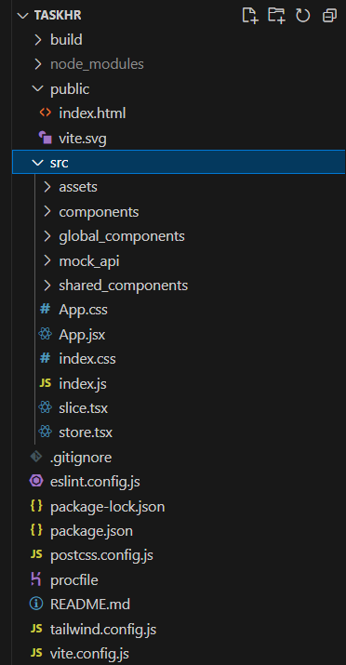

Use minimal external libraries.

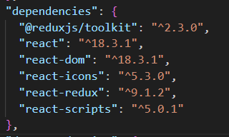

Deploy the website

<https://yraah.github.io/Game-/>

This website is mobile view only.

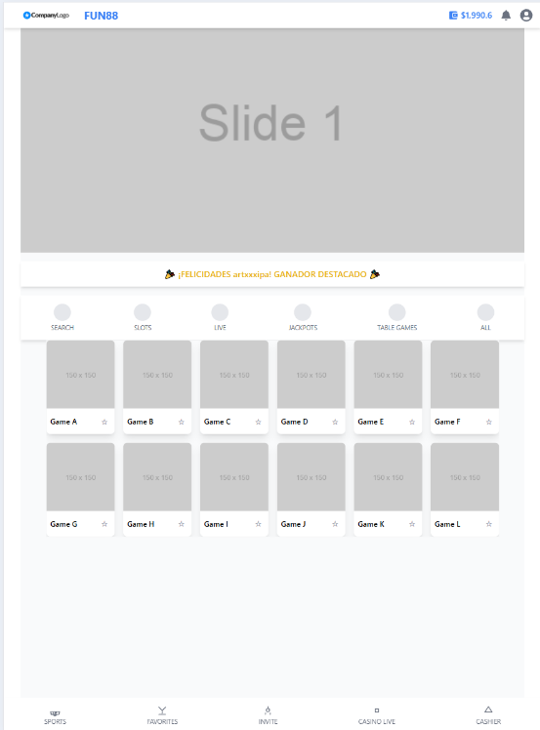

What I want to see:

● How you handle API.

● How you handle different UI states.

● Code readability.

● Code performance.

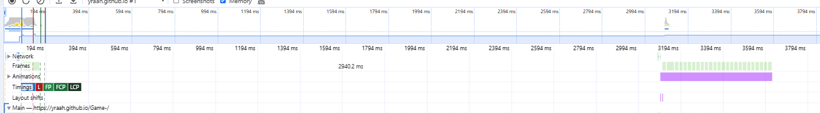

● Your understanding in React.

● Folder structuring

● Use Promise to mock API’s to get the game list, you can use the same images on each game.

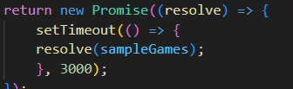

● I should be able to select different categories (START, NEW, SLOTS,...).

● I should be able to search for a game.

● I should be able to filter by Game Provider.

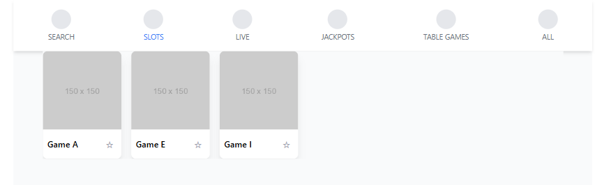

● The banner should be a Carousel. You can use the same image.

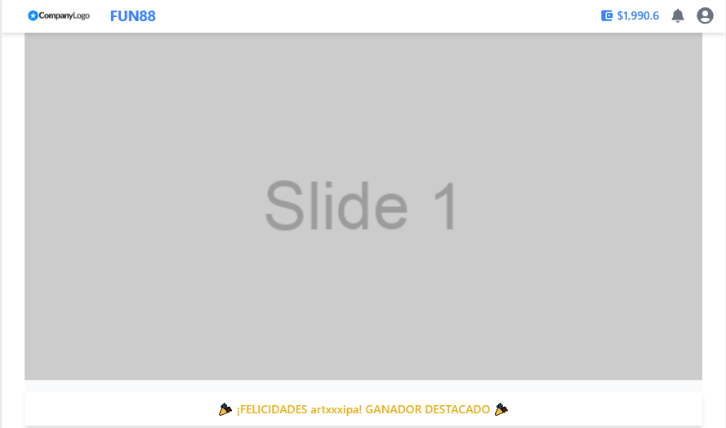

● I should be able to add/remove favorites.

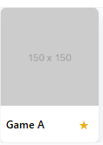

● No need for pixel perfect spacings, paddings, margins. You can just eyeball it.